Become a Sponsor for the

2024 Quest for Success!

TPE's Quest for Success is a premier Midwest conference for performance excellence. Malcolm Baldrige National Quality Award (MBNQA) recipients, TPE award winners, and performance excellence professionals will deliver leading-edge presentations with improvement strategies you can immediately apply to your organization.
Join us for pre-conference activities and the conference on September 9 – 10, 2024 to learn from, engage with, and be inspired by MBNQA award winners and our regional program award recipients. Our attendees - CEOs, middle to senior level executives, directors, heads of operating units, and quality/performance improvement leaders - represent all sectors of the economy and have a passion to drive organizational improvement and effectiveness.
Your sponsorship of the Quest for Success will enhance the conference significantly for the participants, as well as showcase your organization. Conference sponsorship maximizes the return on your investment with influential leaders from across our region. Sponsorships include advertisements on the TPE website, marketing literature and official program, in a variety of announcements during the conference, and acknowledgement on slides prior to plenary sessions.

This year’s conference will take place at the Fawcett Center at The Ohio State University. TPE has reserved blocks of rooms at the Hampton Inn & Suites and Hilton Garden Inn Columbus-University Area. The hotels are within minutes of the conference venue and discounted room reservations can be made online at the TPE website.

Keynote and breakout sessions will include past MBNQA / TPE winners and many other dynamic

presentations and workshops. The conference will provide numerous opportunities to learn about role model best practices, improvement strategies, and benchmark world-class results.

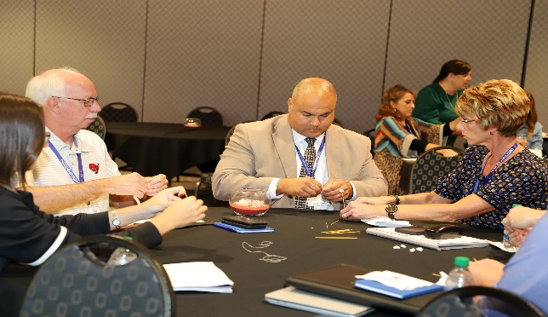
A keynote address will be delivered by Greg Braylock, Jr., Vice President and Chief Diversity, Equity & Inclusion Officer at ProMedica on the impact of diversity on resilience. A panel of MBNQA and TPE award recipients will share how they have adapted, innovated, and thrived. Additional workshops will feature TPE and performance excellence professionals who will provide actionable ideas for you to implement new processes and strengthen the management practices in your organization.

Pre-conference activities include a workshop and awards banquet. An educational and engaging workshop titled The Bridge between Customer and Workforce Engagement: A Shared Relationship Model, will be held September 9th from 1:00 – 4:30 p.m. ET and facilitated by Cindy Burkholder, Maricris Miller, and Andrew Weber of Vandalia Health. 2024 TPE award recipients will be recognized at an awards banquet on September 10th at 6:00 p.m. ET.

You may choose from any number of sponsorship levels. Please select the one that matches your marketing approach and budget. To learn more, contact TPE at (614) 425-7157 to reserve a sponsorship today!

Become a Sponsor Today!

Sponsorship Levels and Benefits

$5,000 and above Platinum Sponsor
- Two complimentary registrations to attend pre-conference activities and conference.
- Recognition of organization at opening of conference, awards banquet, at presentations throughout conference, in conference program and marketing materials.
- Logo will appear on the TPE website.
- Two tickets to Awards Banquet on Monday.
$4,000 Gold Sponsor
- One complimentary registration to attend pre-conference activities and conference.
- Recognition of organization at opening of conference, awards banquet, at presentations throughout conference, in conference program and marketing materials.
- One ticket to Awards Banquet on Monday.
$ 3,000 Silver Sponsor
- Recognition of organization at opening of conference, at presentations throughout conference, in conference program, and marketing materials.
- Two tickets to Awards Banquet on Monday.
$2,000 Bronze Sponsor
- Recognition of your organization at opening of conference, at presentations throughout the conference, and in conference program.
- One ticket to Awards Banquet on Monday.
$50-$1,999 Individual Sponsors
- Listing of your name in conference program.

$650 Exhibitor
- Exhibitor table for both days of the conference.
- All meals for one person including the Awards Banquet Monday evening.
For more information on the conference: https://thepartnershipforexcellence.org
For sponsorship questions, please contact Margot Hoffman at (614) 425-7157. For payment and registration questions, please contact Lauren Browning at (901) 830-4499.
25th Annual
Quest for Success Virtual Conference
Pre-conference Workshop & Awards Banquet – September 9, 2024
Full Day Conference – September 10, 2024, 9:00 a.m. – 4:30 p.m.
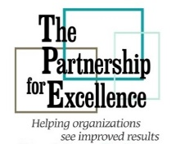

Contributions are tax deductible. TPE is a tax-exempt non-profit organization under IRS section 501(c) 3, E.I.N. 34-1882492.

Please complete this form and return to:
The Partnership for Excellence
829 Bethel Road, #212
Columbus, OH 43214
or Scan & Email to: lauren.browning@thepartnershipforexcellence.org

Sponsorship Form

Organization Name :_________________________

Contact Person: _____________________________

Title: _____________________________________

Address: __________________________________

City: _____________State:______Zip:__________

Phone: __(___)_____________________________

E-Mail:____________________________________

Sponsorship Level
Please indicate your sponsorship level:

_____ Platinum _____ Silver _____ Individual
_____ Gold _____ Bronze _____ Exhibitor

Individual Sponsors, please enter amount of sponsorship: $________

Payment Information

_____ Check here if you are paying by credit card. TPE will email you an invoice with a link to make a secure payment online.

_____ Check here if you have included a check or money order with this application (payable to The Partnership for Excellence)

